Home page:

1. Navigation
2. Showcase



1. About us / services

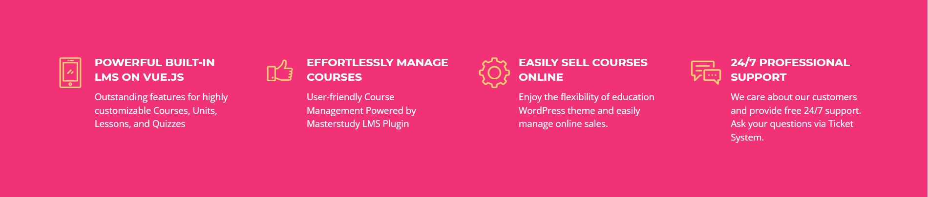



1. Course categories

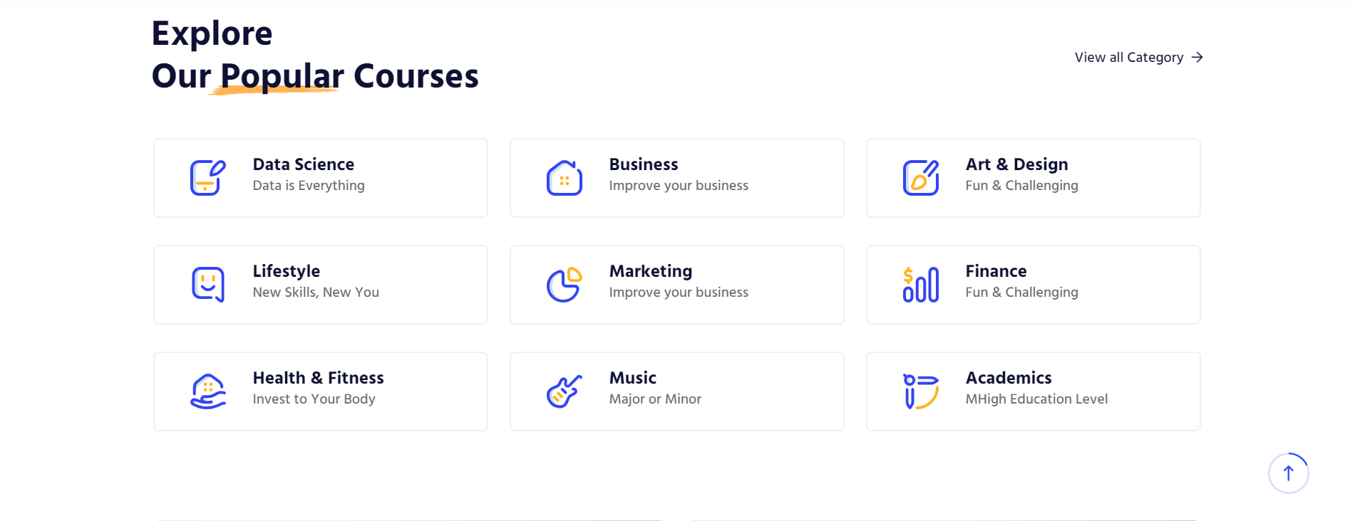

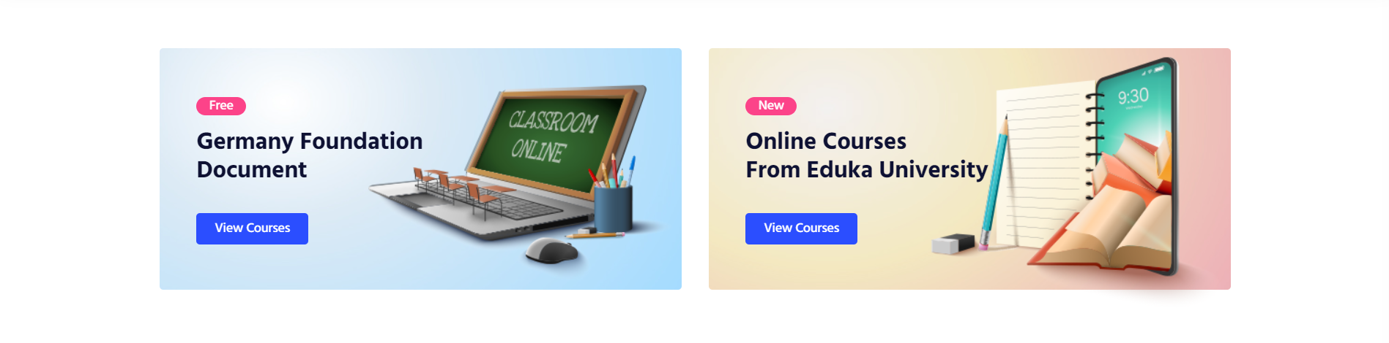

1. Course filtering

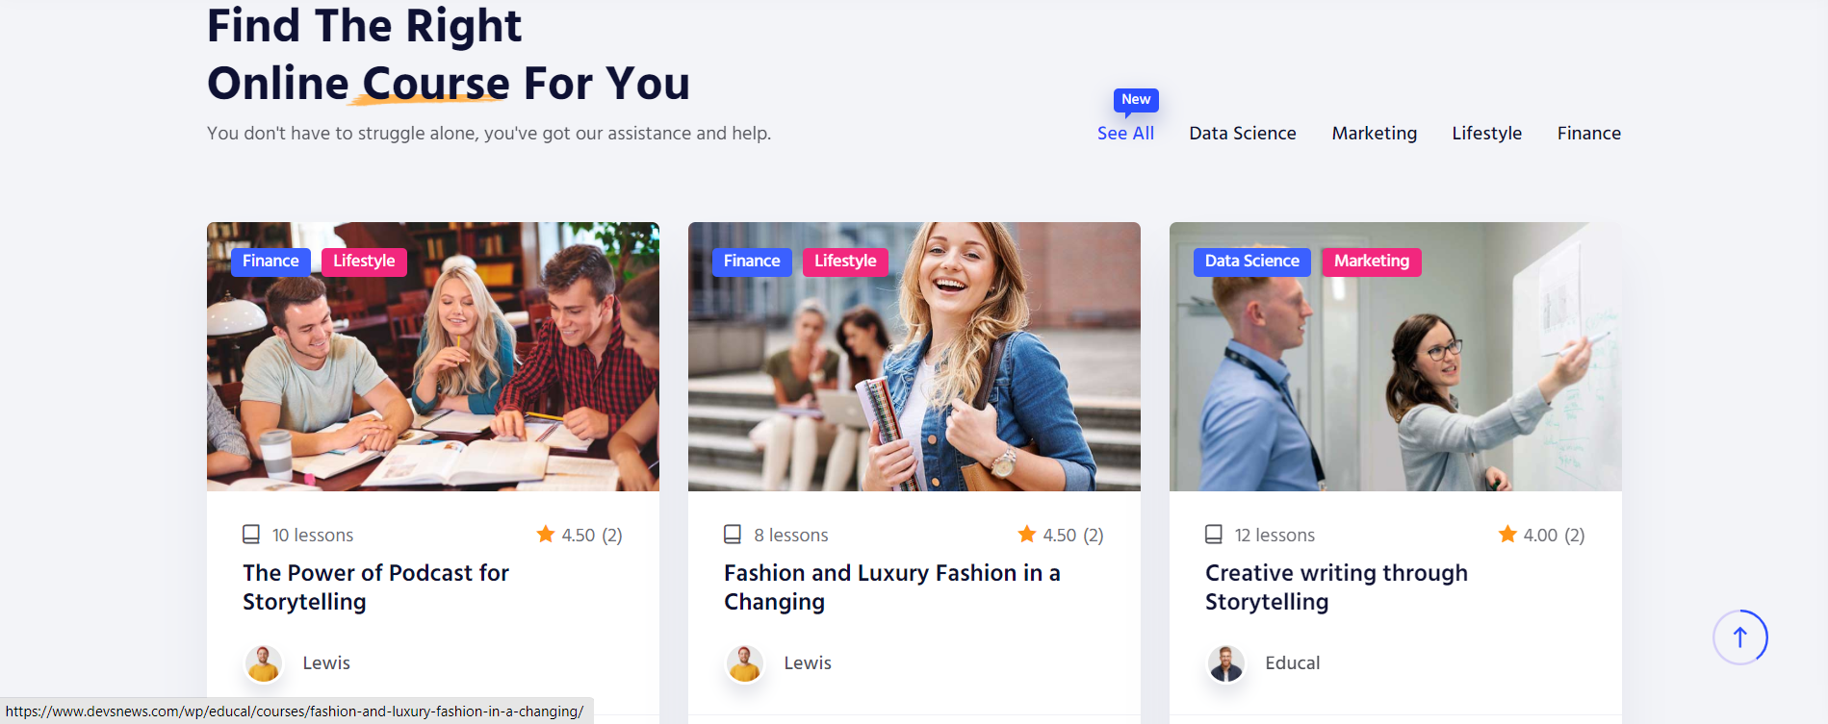

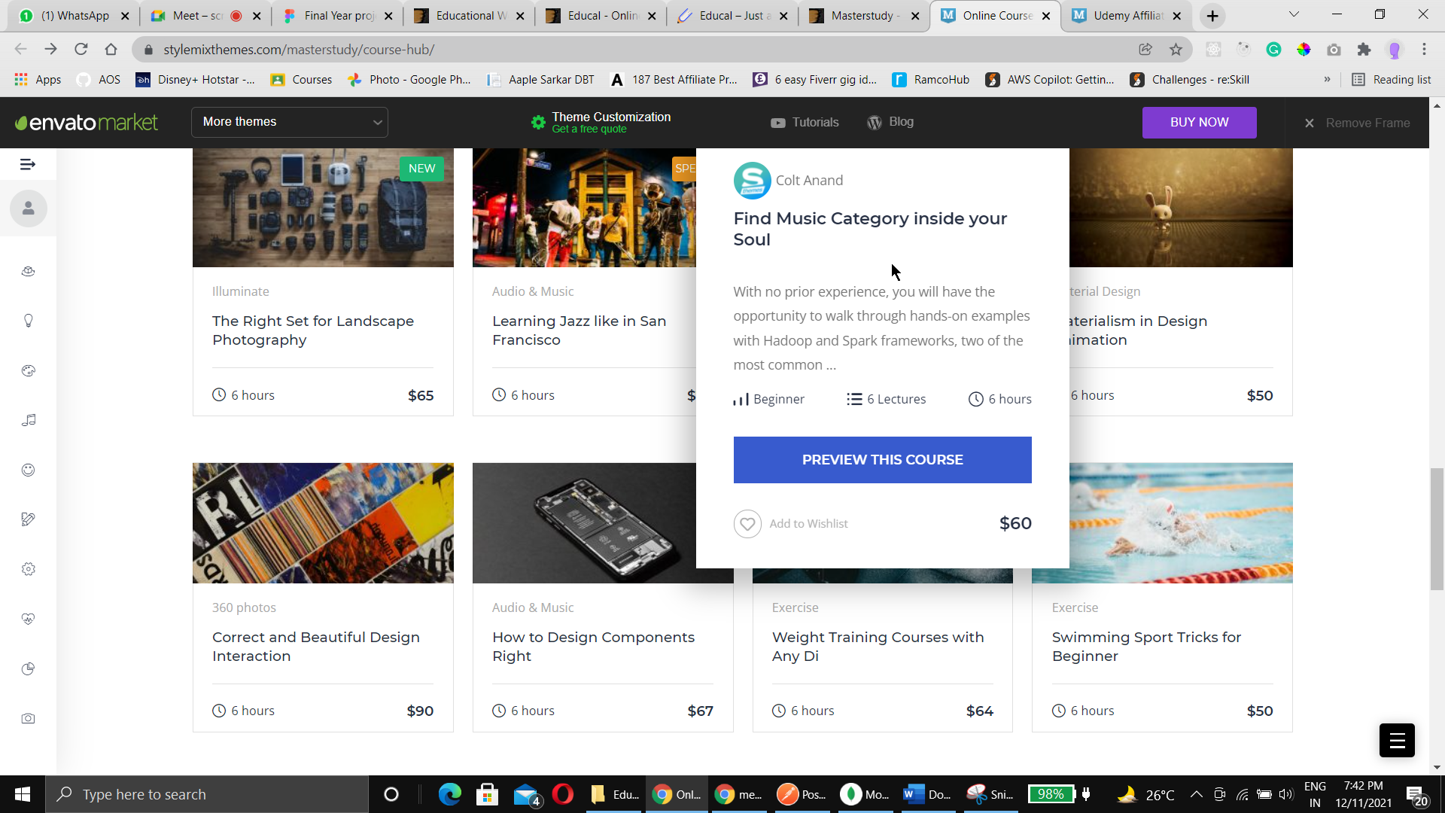

1. Call to action



1. Footer

About Page

Login page

Samples:

Register page

Courses page

Particular course page

Course lessons